7:00 PM Wine Reception
7:30 PM GRAND MARCH

DANCE PROGRAM

The Machine Without Horses (J) RSCDS Bk 12

Delvine Side (S) RSCDS Bk 2

Maxwell’s Rant (R) RSCDS Bk 18

Joie de Vivre (J) RSCDS Bk 39

The Lammermuir Hills (S) Goldring-Wells House

Bratach Bana (R) Bon Accord

A Capital Jig (J) 6 for 2009

Fair Donald (S) RSCDS Bk 29

Da Rain Dancin’ (R) From the Redwoods

Interval

Pelorus Jack (J) RSCDS Bk 41

1314 (S) Drewry, Rondel Bk

Waverley/Fugal Fergus (J) RSCDS Bk15/Foss Waverley Fugues

The Spirit of the Dance (S) TAC 50thAnniv

The Flowers of Edinburgh (R) RSCDS Bk 1

Major Ian Stewart (J) RSCDS Bk 35

City of Belfast (S) RSCDS Bk 48

Sleepy Maggie (R) RSCDS Bk 11

Crib sheets available for download on website
www.rscds-seattle.org

Summer Ball
RSCDS-Seattle

8 June 2019
Leif Erikson Hall, Ballard

Music by

Giants’ Causeway Scottish
Country Dance Band

Cayley Schmid – Fiddle
Clea Johnson – Cello
David Pender Lofgren - Drums

Alan Roberts – Sound

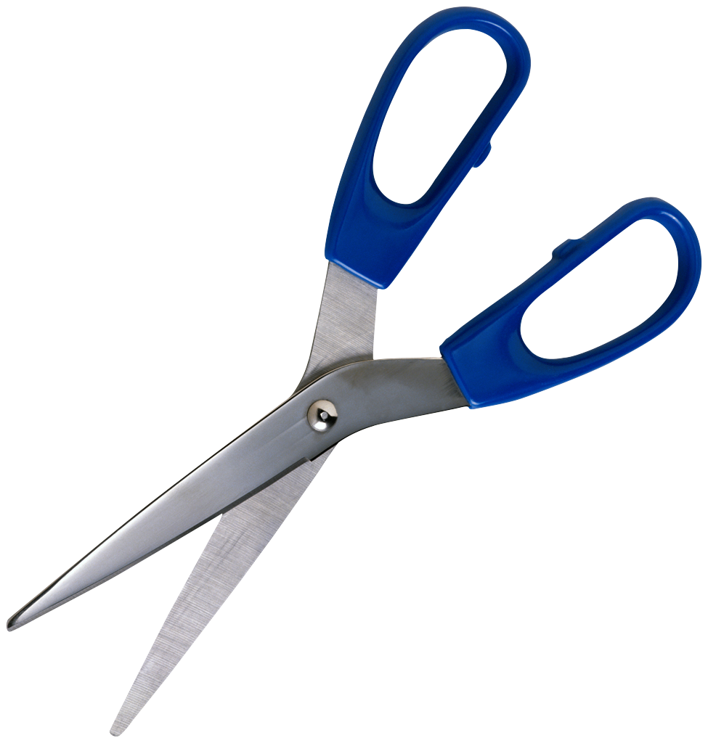
TICKETS

55 USD PER PERSON by 31 March
60 USD by 24 May
65 USD at the door

NAME(S) ______________________________________

_______________________________________

ADDRESS _______________________________________

_______________________________________

PHONE _______________________________________

E-MAIL _______________________________________

Please make cheques payable to
RSCDS-Seattle Branch and mail to:

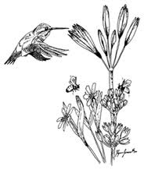
Jenny Prior
12922 NE 71st Street
Kirkland, WA 98033

jennyscout@aol.com

(425) 822-9594
Jenny is the registrar—if you have questions
please contact her

The Ball will be held at

Leif Erikson Hall
2245 NW 57th Street
Seattle, WA 98107
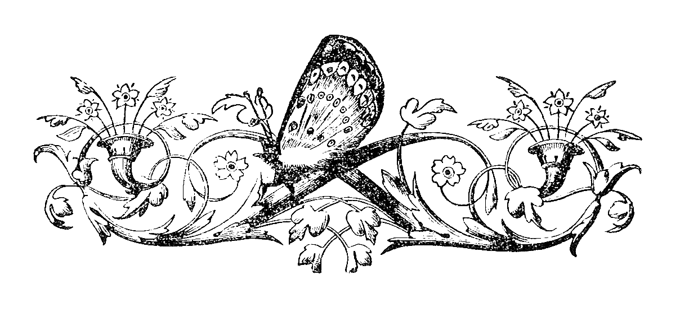

Helpful information

There is parking for about 20 cars at
Leif Erikson Hall and additional
parking is available in a pay lot across the
street or in the bank lot next to hall,
or on the street.

Metro Transit routes stopping
close to the hall on Saturdays,
44, and Rapid Ride “D” line

Seattle has many hotels; here are a few
in various price ranges which are within
5 miles of Leif Erikson Hall

Ballard Inn – 206.789.5011
Hotel Ballard – 206.789.5012
College Inn – 206.633.4441
University Motel Suites – 206.522.4724
Graduate Seattle – 206.634.2000
Dibble House B & B – 206.783.0320

