The Romance of Dance
Tacoma Annual Dance - Feb. 22, 2026

Highland Fair (J)

Rovin’ Robin (R)

Sugar Candie (S)

Follow Me Home (J)

Asilomar Romantic (S)

Luckenbooth Brooch (J)

Wind That Shakes the Barley (R)

~ INTERMISSION ~

The Kissing Bridge (J)

Mairi’s Wedding (R)

Triple Happiness (S)

Chased Lovers (J)

John McAlpin (S)

Reel of the Royal Scots (R)

See below for table with role, key figures, and why included.
Further down are cribs and Pilings diagrams

Table Form
Role | Dance Name | Type | Key Figures | Why include
Starting Dance  1st | Highland Fair | (J8x32)  2C (4C set) | Cast D&U, DMU, R&L | Inclusive, easy  Featured list dance & repeat  Courting happened at Fairs
2nd Dance | Rovin’ Robin | (R8x32)  2C (4C set) | Fig 8, DMU, Alle | Inclusive, easy  Devisor’s Choice  Nod to Robbie Burn’s Amorous Inclinations
3rd Dance | Sugar Candie | (S8x32) | 3HR, CPCP, R3 | Moderate  Featured list dance & because love is sweet as sugar candy
4th Dance | Follow Me Home | (J8x32) 3C (4C set) | BIL, R3 | Moderate  Featured List Dance  Romantic Innuendo
5th Dance | Asilomar Romantic | (S8x32)  3C (4C set) | Dbl Fig 8,  Dmnd Pous, CPCP | Advanced  Featured list dance & repeat  Romantic CA Beaches
6th Dance | Luckenbooth Brooch | (J8x32) 3C (4C set) | Meanwhile | Moderate  Devisor’s Choice  The Luckenbooth Brooch is an enduring Scottish symbol of love
7th Dance End 1st Half | Wind That Shakes The Barley | (R8x32) 3C (4C set) | DMU, R3, S&T Crnrs, 6HR | Moderate, energetic for ending first half  Featured list dance  Sad doomed love story
INTERMISSION
8th Dance ReStart | The Kissing Bridge | (R8x32) 3C (4C set) | Opposite reels, quick-time pousette | Easy  Devisor’s Choice  Title/ Theme, Figures add pizazz
9th Dance | Mairi’s Wedding | (R8x40) 3C (4C set) | R4, R3, 6HR | Moderate  Featured List Dance  Wedding theme, Loved by many
10th Dance | John McAlpin  9 minutes long | S | A&R, Turn CPC, Circle | Easy  Repeat  Flirty dance
11th | Chased Lovers | (J8x32) 3C (4C set) | Tandem R3  CPT | Moderate,  Devisor’s Choice  Title/Theme
12th | Triple Happiness | (S3x32) 3C | Knot, Crnrs P&T, Chase, Twirl | Advanced  Featured List Dance  Love should make you 3x happy
13th Last Dance | Reel of the Royal Scots | (R8x32) 3C (4C set) | Dbl Triangles, 6HR | Moderate, High Energy  Featured List Dance & Repeat From Nov  Many Love it
Waltz
Extra | MacDonald of Keppoch | Medley |  | Moderate  Nov Repeat
Extra | Jubilee Jig | (J8x32) 3C (4C set) | HA | Easy  Featured List & Repeat  A wedding is a Jubilee

STATS for program
- 13 Dances Total + 2 Extra
- 8 (+1) Dances from Featured List (62%)
- 4 repeats from Nov. & Dec. (33%) + 2 of extras (7/15 = 47%)
- 4 jigs, 5 reels, 4 strathspeys
- 4(+1) easy, 6(+1) moderate, 2 advanced
- Figure distribution – pousettes, reels, Knot, CPC, dbl triangles, R&L, meanwhiles

Cribs and Pilings Below
THE HIGHLAND FAIR (J8x32) 2C (4C set) Book of Graded SCDs
1- 8 1s cast, dance down behind own lines, turn outwards and dance back to place
9-16 1s+2s turn partners RH back to place and then turn LH
17-24 1s followed by 2s, lead down the middle and 2s lead back to the top
25-32 2s+1s dance R&L
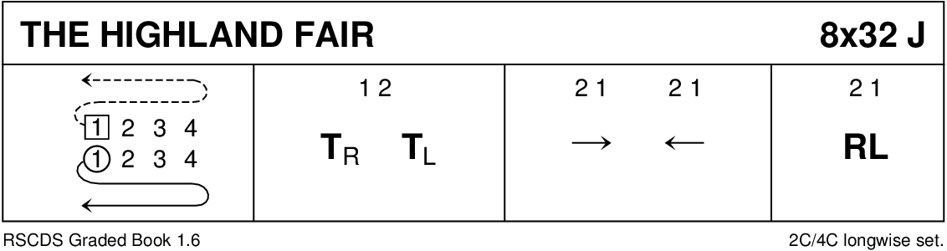
https://www.scottish-country-dancing-dictionary.com/video/highland-fair.html

ROVIN' ROBIN (R8x32) 2C (4C set) Alex Gray SCD Archives
1- 8 1M dances a Fig of 8 round 1L and 2L passing 2L by RSh to start, 2L turns right about bars 1-4 and 1L turns left about bars 5-8
9-16 1M+2L lead down the middle and back to top (1L dances down 1 place)
17-24 1M+2L also 2M+1L dance Allemande
25-32 1M+2L turn RH, 1M+1L turn LH to 2nd places (2L steps up)
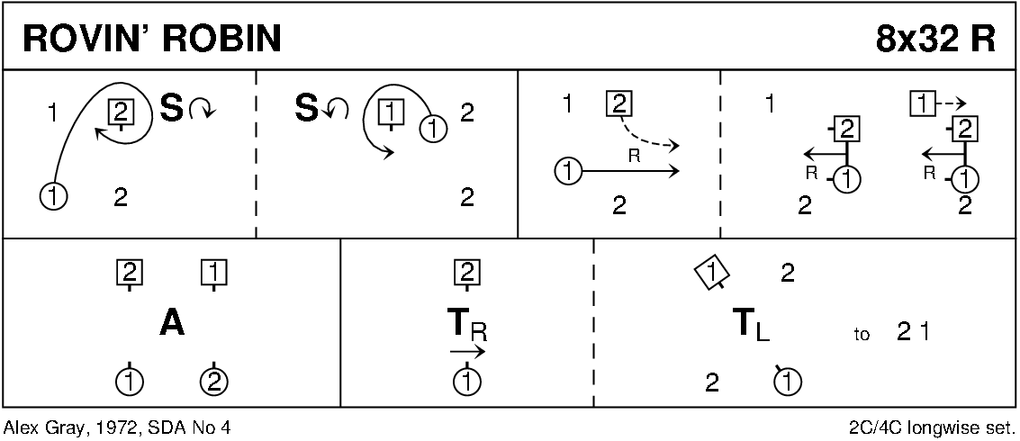
Rovin' Robin - Scottish Country Dancing Instruction Video
The title of this dance, Rovin' Robin, comes from the Rantin' Rovin' Robin - Song written by Robert Burns appearing in his Second Commonplace Book in 1787 when he was 28.

FOLLOW ME HOME (J8x32) 3C (4C set) Ellie Briscoe RSCDS Book 38
1- 8 1s set and cross RH, cast 1 place and turn LH (ending in a diagonal line LH to partner and RH with 1st corner)
9-16 1s Balance-in-Line with 1st corners, ½ turn corners and 1s followed by corners chase clockwise to 3rd corner (position), 1s dance in, join RH with partner and LH with 2nd corners
17-24 1s Balance-in-Line with 2nd corners, ½ turn corners and 1s followed by corners chase anticlockwise to 4th corner (position), 1s crossing LSh to 2nd place opposite sides facing out
25-32 3s+1s+2s dance ½ reels of 3 on the sides 1s giving LSh to 2nd corner (position); 2s+1s+3s set and cross RH. 213
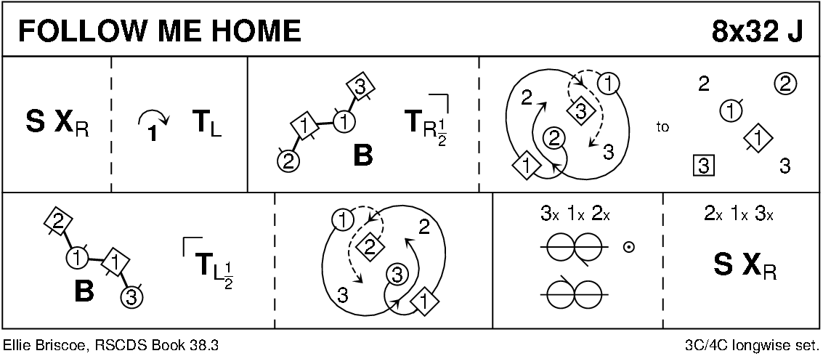
Follow Me Home - Scottish Country Dance Video

ASILOMAR ROMANTIC (S8x32) 3C (4C set) Tom Cuthbertson San Fransisco Collection 2
1- 8 1s+3s dance double Fig of 8 around 2s, 1s crossing down, 3s cast up to start
9-16 1s+2s dance Poussette
17-24 1s dance in and down between 2s (2s step up), set to each other and dance RSh round 4th corner to face own 1st corner
25-32 1s dance 'Hello-Goodbye' setting ending with petronella turn to 2nd places. 213
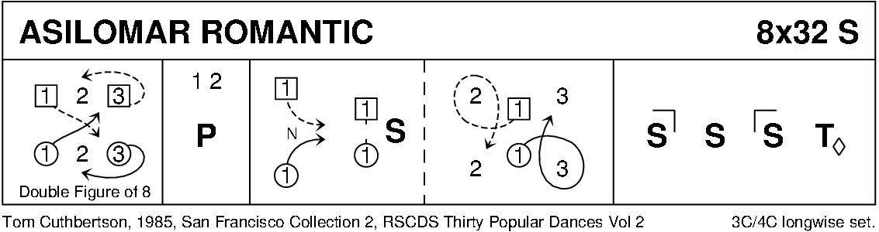

THE LUCKENBOOTH BROOCH (J8x32) 3C (4C set) John Bowie Dickson Glendarroch Sh 28
1- 8 1s in prom hold (Lady on Man's left) dance reel of 3 with 2s (RSh to 2M) and end facing 3M
9-16 1s dance reel with 3s (RSh to 3M) ending with 1s dancing into centre facing Men's side
17-24 1M casts up and 1L down into centre and dance out Ladies' side, 1M cast up and 1L down to end 1M between 2s facing down and 1L+3s face up as 2s+3s dance R&L
25-32 2s+1s+3s set twice, 1s turn RH 1¾ times to 2nd places
Note: 2nd time through bars 29-32: 1s turn ¾ RH and dance down to 4th place (4s step up)
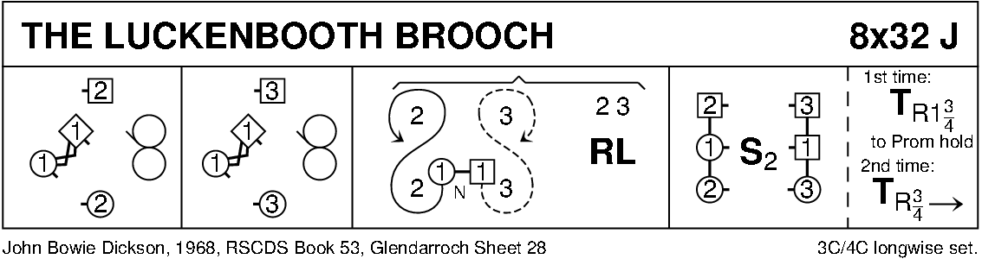
https://www.scottish-country-dancing-dictionary.com/video/luckenbooth-brooch.html
The luckenbooth brooch is a traditional Scottish wedding brooch given to the bride by the groom on their wedding day, and subsequently pinned to the shawl of the first baby to protect it from "evil spirits".
THE WIND THAT SHAKES THE BARLEY (R8x32) 3C (4C set) John M Duthie 8 SCDs
1- 8 1s lead down for 3 steps, lead back to top of set and cast into 2nd place on own sides
9-16 1s dance reels of 3 across, (1M with 2s and 1L with 3s), RSh to 2nd corner
17-24 1s turn 1st corner, partner, 2nd corner, partner
25-32 All circle 6H round and back
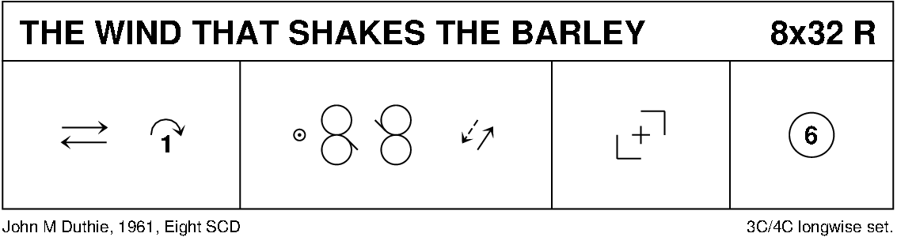
https://www.scottish-country-dancing-dictionary.com/video/wind-that-shakes-the-barley.html
~ INTERMISSION ~
THE KISSING BRIDGE (R8x32) 3C (4C set) Romaine Butterfield RSCDS Book 47
1- 8 1s cast and dance behind lines to bottom and turn outwards to dance back to top
9-16 1s cross down to dance reels of 3 on opposite sides to end in partner's place
17-24 1s lead down middle and cross to own sides (Lady under Man's arm), 1s lead up to top and end facing partner with 2H joined
25-32 1s+2s dance Poussette. 213
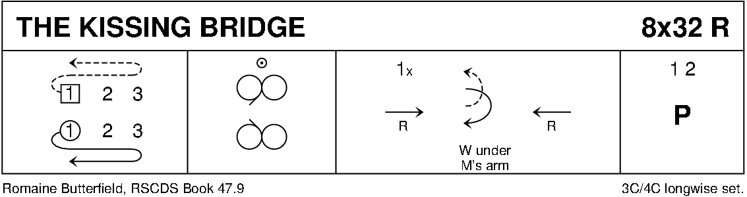
https://www.scottish-country-dancing-dictionary.com/video/kissing-bridge.html

MAIRI'S WEDDING (R8x40) 3C (4C set) James B. Cosh 22 SCDs
1- 8 1s turn RH and cast to 2nd place (2s step up); 1s turn LH to face 1st corners
9-16 1s dance ½ diagonal reel of 4 with 1st corners, 1s dance ½ diagonal reel with 2nd corners
17-24 1s dance ½ diagonal reel with 3rd corner (positions), ½ diagonal reel with 4th corner (positions)
25-32 1s dance reel of 3 across (Lady with 2s, Man with 3s - LSh to 1st corner)
33-40 2s+1s+3s circle 6H round and back. 213
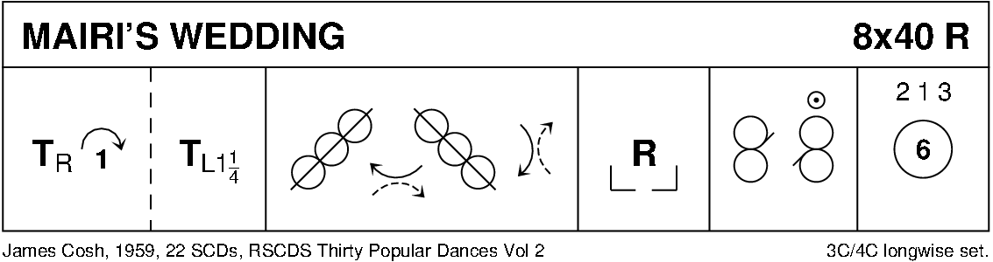

TRIPLE HAPPINESS (S3x32) 3C Yoshiki Oyama RSCDS Book 52
1- 8 1s advance and retire (1 step each) taking RH briefly, 1s ½ turn LH, cross down between 2s and cast up to place
9-16 1s+2s dance the Knot. 1s end facing 1st corners
17-24 1s dance Corners pass and turn with 1st corners, pass RSh, Repeat with 2nd corners and 1s pass RSh into 2nd place own sides (corners turn 2H in centre)
25-32 All chase clockwise ½ round to opposite sides, all ½ turn 2H, pull back RSh and dance out to own sides. 312
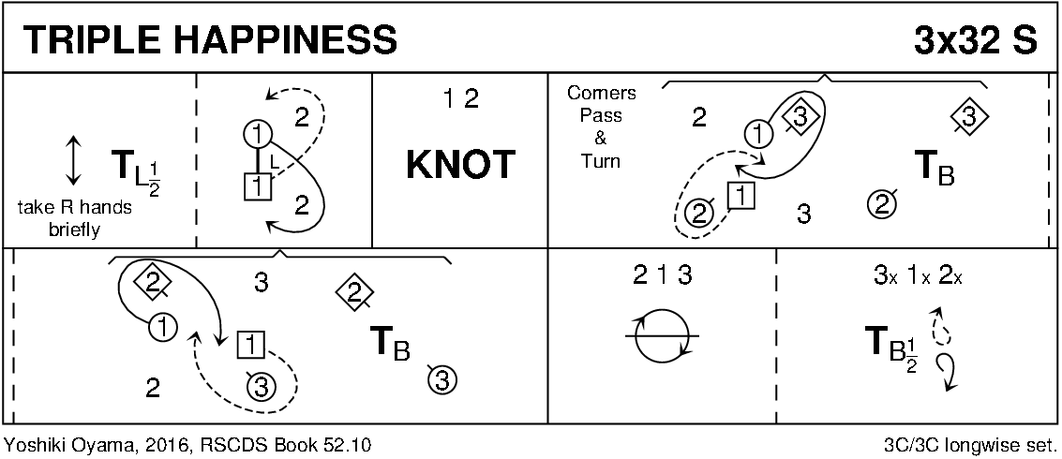

CHASED LOVERS (J8x32) 3C (4C set) Tim Wilson World Wide Weavings 2015 and RSCDS book 53
1- 4 1s set, cross down (no hands) to 2nd place facing out (2s step up 3-4)
5- 8 1s cast down behind 3s, meet and dance up centre with 1L leading, 1M following, to face 2M (her 1st corner)
9-16 1s, in tandem, dance LSh reel of 3 on 1st corner diagonal (out of top of set to start), finishing by 1s pulling back RSh to face down, 1M leading, facing 3M
17-24 1s, in tandem, dance RSh reel of 3 on 2nd corner diagonal (out bottom of set to start), finishing with 1s facing own 1st corners
25-32 1s dance pass and turn with 1st corners, (pass RSh), pass and turn with 2nd corners, finishing passing RSh to 2nd place own sides
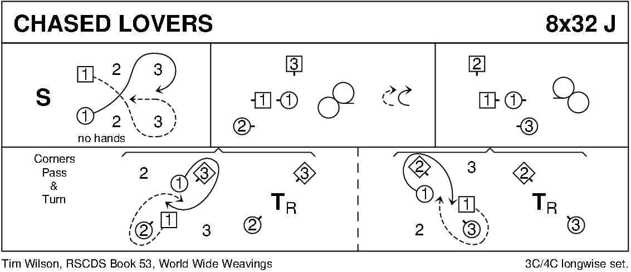
https://www.scottish-country-dancing-dictionary.com/video/chased-lovers.html

JOHN MCALPIN (S8x32) 3C (4C set) Hugh Foss Galloway Album
1- 8 1s advance and retire 1 step (touch RH) and cross LH, lead down RH 1 place and ¾ turn LH to face 1st corners
9-16 1s turn RH 1st corner and turn partner LH, turn RH 2nd corner then cross LH to 2nd place own sides
17-24 2L+1L+3L set, advance and retire and set while 2M+1M+3M stand for 2 bars, set, advance and retire
25-32 2s+1s+3s cross RH, circle 6H round to left ½ way, cross LH and circle 6H round to right ½ way
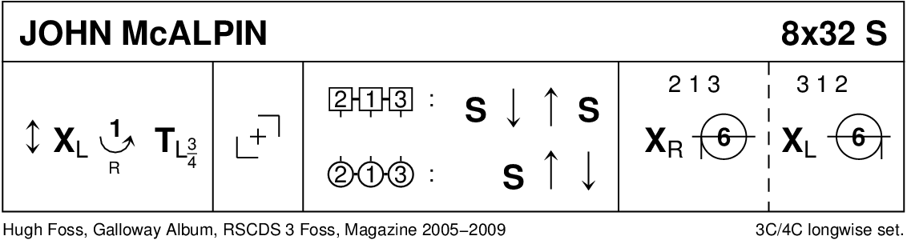
https://www.scottish-country-dancing-dictionary.com/video/john-mcalpin.html

THE REEL OF THE ROYAL SCOTS (R8x32) 3C (4C set) Roy Goldring RSCDS Leaflet Dances 27
1- 4 1s ½ turn 2s on sides (1M RH - 1L LH) to 1s in centre BtoB facing out, 2s+1s+3s set
5- 8 1s ½ turn 3s on sides (1M LH - 1L RH) to 3s in centre BtoB facing out and 2s+3s+1s set
9-16 1s followed by 3s dance up between 2s, cast down 1 place; 1s dance down between 3s and cast up to 2nd place, 3s loop into 3rd place
17-24 1s turn 1st corners RH, pass partner RSh turn 2nd corners RH and cross passing partner RSh to 2nd place own sides
25-32 2s+1s+3s circle 6H round and back
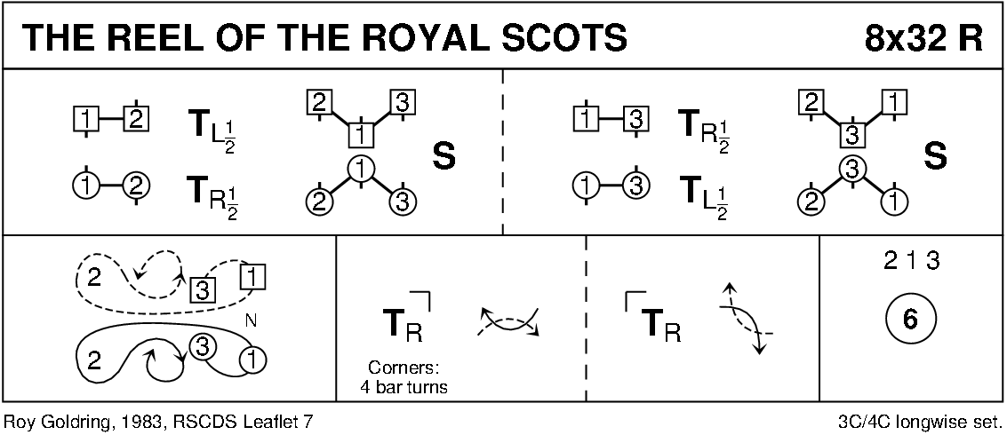
Possible Alternate Choice Dances
C'EST L'AMOUR (The Flirt) (J8x32) 3C (4C set) RSCDS Book 34
1- 8 1L casts 1 place and sets, casts to 3rd place and sets
9-16 1s cast up/down to 2nd place and set, 1L casts up into middle facing down while 1M casts down 1 place into middle facing up and both set
17-24 1s circle 3H round and back (Lady with 2s and Man with 3s) ending facing 2s/3s (2s facing up and 3s down)
25-32 1s+2s+3s set, 1s dance under arches made by 2s/3s to 2nd place own sides and 2s+1s+3s turn RH
THE JUBILEE JIG (J8x32) 3C (4C set) RSCDS Leaflet Dances 11
1- 8 1M casts to 2nd place (2M step up), sets to 3L, turns RH and dances back to 2nd place on own side
9-16 1L casts to 2nd place (2L step up), sets to 3M, turns LH and dances back to 2nd place
17-24 1L with 2s and 1M with 3s dance RH across, 1s end in centre LH joined, 1s set in centre and dance out to 2nd place on opposite sides
25-32 1M with 2s and 1L with 3s dance RH across, 1s end in centre LH joined, 1s set in centre and dance out to 2nd place on own sides

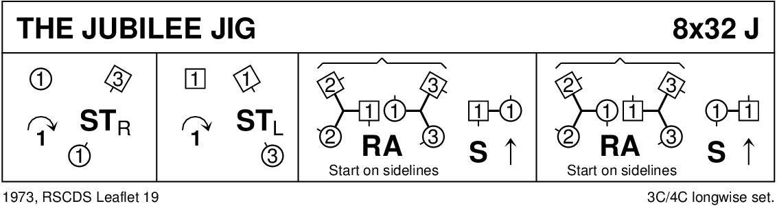
https://www.scottish-country-dancing-dictionary.com/video/jubilee-jig.html

CATCH THE WIND (R8x32) 3C (4C set) Romaine Butterfield RSCDS Book 45
1- 8 1s set, cast 1 place and dance ½ Fig of 8 round 2s
9-16 1s set twice with 1L pulling back RSh on bars 11-12 to face out, 1L followed by partner casts up and dances down the middle 1L to face 3M while 1M faces 2M
17-24 1s RSh reels of 3 across (1M with 2s and 1L with 3s)
25-32 1L followed by partner dances down cast up round 3M and crosses to end in 2nd place on own sides, 1s turn RH (4 bars)
SUGAR CANDIE (S8x32) 3C (4C set) RSCDS Book 26
1- 8 1s set and cast 1 place (2s step up); 1s cross passing LSh and cast RSh round their 1st corner into centre ending BtoB (Lady facing up, Man down)
9-16 1L+2s and 1M+3s circle 3H round to left, turn to face partner and set, 1s ¾ turn partner 2H to end facing 1st corners
17-24 1s turn 1st corner RH, partner LH, 2nd corner RH, partner LH and end facing 1st corners
25-32 1s dance 6 bar LSh reel of 3 on opposite sides (pass 1st corner LSh), 1s cross RH to 2nd place own sides
THE LOVERS' KNOT (S8x40) 3C (4C set) RSCDS Book 8
Music: SCD Vol. 3 (Colin Dewar) #10 “Leatham Ladies”
1- 8 1s dance full Fig of 8 round 2s
9-16 1s set twice and turn 2H twice
17-24 1s lead down the middle and back to face 1st corners
25-32 1s set and turn 1st corners, set and turn 2nd corners
33-40 1s dance reels of 3 on opposite sides giving LSh to 1st corners, 1s cross to 2nd place own sides
Title fits theme but music is blah and video makes it look boring!
Alternate tune might help.

THE SILVER TASSIE (S8x32) 3C (4C set) John Drewry Bon Accord Book
1- 8 1s+2s+3s cross RH and set, cross back RH and set
9-16 1s and 3s dance double Fig of 8 round 2s (3s casting)
17-24 1s followed by 2s+3s dance down, 1s followed by 2s+3s (who part to let 1s through) dance back to top
25-32 1s+2s dance the Rondel. 213
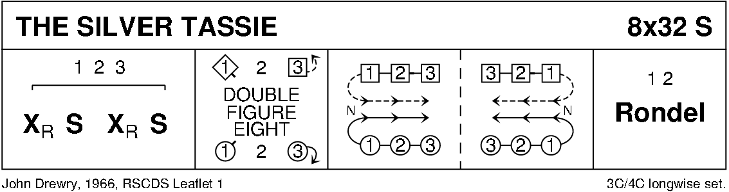
https://www.scottish-country-dancing-dictionary.com/video/silver-tassie.html

